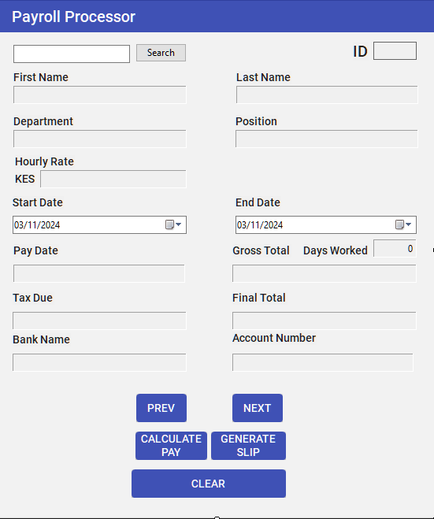

Imports iTextSharp.text

Imports iTextSharp.text.pdf

Imports System.IO

Public Class frmPayroll

Private connectionString = My.Settings.ConnectionString

' With these we can store employee data temporarily while reading from the DB and navigate through records sequentially

Private currentRecordIndex As Integer = 0

Private employeeDataTable As DataTable

Private Sub frmPayroll_Load(sender As Object, e As EventArgs) Handles MyBase.Load

LoadEmployeeRecords()

End Sub

Private Sub LoadEmployeeRecords()

Using connection As New OleDbConnection(connectionString)

Try

connection.Open()

Dim query As String = "SELECT Employees.*, Accounts.AccountNumber, Accounts.BankName " &

"FROM Employees " &

"INNER JOIN Accounts ON Employees.EmployeeID = Accounts.EmployeeID " &

"WHERE Employees.Active = True " &

"ORDER BY Employees.EmployeeID"

Dim adapter As New OleDbDataAdapter(query, connection)

employeeDataTable = New DataTable()

adapter.Fill(employeeDataTable)

If employeeDataTable.Rows.Count > 0 Then

currentRecordIndex = 0

PopulateEmployeeDetails(currentRecordIndex)

Else

MessageBox.Show("No active records found.")

End If

Catch ex As Exception

MessageBox.Show("Error loading data: " & ex.Message)

End Try

End Using

End Sub

Private Sub PopulateEmployeeDetails(index As Integer)

If employeeDataTable IsNot Nothing AndAlso employeeDataTable.Rows.Count > index AndAlso index >= 0 Then

Dim row As DataRow = employeeDataTable.Rows(index)

IDLabelText.Text = row("EmployeeID").ToString()

lblFirstName.Text = row("FirstName").ToString()

lblSecondName.Text = row("LastName").ToString()

lblDepartment.Text = row("Department").ToString()

lblPosition.Text = row("Position").ToString()

lblRate.Text = Convert.ToDecimal(row("HourlyRate")).ToString()

lblAccNo.Text = row("AccountNumber").ToString()

lblBank.Text = row("BankName").ToString()

End If

End Sub

Private Sub ClearDates()

dtpStart.CustomFormat = ""

dtpEnd.CustomFormat = ""

End Sub

Private Sub Clear_Click(sender As Object, e As EventArgs) Handles btnClear.Click

txtSearchBox.Text = ""

ClearDates()

End Sub

Private Sub CalcPay_Click(sender As Object, e As EventArgs) Handles btnCalcPay.Click

Dim startDate As Date = dtpStart.Value

Dim endDate As Date = dtpEnd.Value

Dim rate As Decimal = CInt(lblRate.Text)

Dim difference As TimeSpan = (endDate - startDate)

Dim totalDays As Integer = CInt(difference.TotalDays) + 1

' We assume they are working only 8hrs and not being paid overtime and a flat Tax Rate of 12.5%

Dim totalPay As Decimal = rate * totalDays * 8

Dim tsxDue As Decimal = totalPay * 0.125

Dim finalTotal As Decimal = totalPay - tsxDue

' Prevent time travel and silly values like negative working days

If totalDays <= 0 Then

MessageBox.Show($"Unless your employee is a time traveller, I don't see how they could have achieved working {totalDays} days. Check your math!")

Else

lblDaysWorked.Text = totalDays.ToString()

lblGross.Text = "KES " + totalPay.ToString()

lblPayDate.Text = endDate.AddDays(1).ToString()

lblTax.Text = tsxDue.ToString()

lblNetTotal.Text = finalTotal.ToString()

End If

End Sub

Private Sub PreviousRecord_Click(sender As Object, e As EventArgs) Handles btnPreviousRecord.Click

If currentRecordIndex > 0 Then

currentRecordIndex -= 1

PopulateEmployeeDetails(currentRecordIndex)

Else

MessageBox.Show("There are no more employees before this one.")

End If

End Sub

Private Sub NextRecord_Click(sender As Object, e As EventArgs) Handles btnNextRecord.Click

If currentRecordIndex < employeeDataTable.Rows.Count - 1 Then

currentRecordIndex += 1

PopulateEmployeeDetails(currentRecordIndex)

Else

MessageBox.Show("Congratulations! You reached the end of the records.")

End If

End Sub

Private Sub Search_Click(sender As Object, e As EventArgs) Handles btnSearch.Click

Dim searchID As String = txtSearchBox.Text.Trim()

Dim employeeID As Integer

If String.IsNullOrEmpty(searchID) OrElse Not Integer.TryParse(searchID, employeeID) Then

MessageBox.Show("Please enter a valid numeric Employee ID.")

Return

End If

Using connection As New OleDbConnection(connectionString)

Try

connection.Open()

Dim query As String = "SELECT Employees.*, Accounts.AccountNumber, Accounts.BankName " &

"FROM Employees " &

"INNER JOIN Accounts ON Employees.EmployeeID = Accounts.EmployeeID " &

"WHERE Employees.EmployeeID = @EmployeeID"

Dim command As New OleDbCommand(query, connection)

command.Parameters.AddWithValue("@EmployeeID", employeeID)

Using reader As OleDbDataReader = command.ExecuteReader()

If reader.Read() Then

IDLabelText.Text = reader("EmployeeID").ToString()

lblFirstName.Text = reader("FirstName").ToString()

lblSecondName.Text = reader("LastName").ToString()

lblDepartment.Text = reader("Department").ToString()

lblPosition.Text = reader("Position").ToString()

lblRate.Text = Convert.ToDecimal(reader("HourlyRate")).ToString()

lblAccNo.Text = reader("AccountNumber").ToString()

lblBank.Text = reader("BankName").ToString()

Else

MessageBox.Show("Employee ID not found.")

End If

End Using

Catch ex As Exception

MessageBox.Show("Error searching for employee: " & ex.Message)

End Try

End Using

End Sub

Private Sub Play_Click(sender As Object, e As EventArgs) Handles btnPlay.Click

Dim savePath As String = Path.Combine(Environment.GetFolderPath(Environment.SpecialFolder.Desktop), $"{lblFirstName.Text}{lblSecondName.Text}-{Date.Now.ToString("yyyy-MM-dd")}{Date.Now.ToString("ss")}.pdf")

Dim pdfDoc As New Document(PageSize.A4, 40, 40, 40, 20)

Try

PdfWriter.GetInstance(pdfDoc, New FileStream(savePath, FileMode.Create))

pdfDoc.Open()

Dim titleFont As New Font(iTextSharp.text.Font.FontFamily.HELVETICA, 16, iTextSharp.text.Font.BOLD)

Dim regularFont As New Font(iTextSharp.text.Font.FontFamily.HELVETICA, 12, iTextSharp.text.Font.NORMAL)

'Title

pdfDoc.Add(New Paragraph($"PaySlip: {lblFirstName.Text} {lblSecondName.Text}", titleFont))

pdfDoc.Add(New Paragraph(Environment.NewLine))

'Body

pdfDoc.Add(New Paragraph("Employee ID: " & IDLabelText.Text, regularFont))

pdfDoc.Add(New Paragraph("First Name: " & lblFirstName.Text, regularFont))

pdfDoc.Add(New Paragraph("Last Name: " & lblSecondName.Text, regularFont))

pdfDoc.Add(New Paragraph("Department: " & lblDepartment.Text, regularFont))

pdfDoc.Add(New Paragraph("Position: " & lblPosition.Text, regularFont))

pdfDoc.Add(New Paragraph("Hourly Rate: " & lblRate.Text, regularFont))

pdfDoc.Add(New Paragraph("Start Date: " & dtpStart.Value.ToString(), regularFont))

pdfDoc.Add(New Paragraph("End Date: " & dtpEnd.Value.ToString(), regularFont))

pdfDoc.Add(New Paragraph("Total Days Worked: " & lblDaysWorked.Text, regularFont))

pdfDoc.Add(New Paragraph("Gross Pay: " & lblGross.Text, regularFont))

pdfDoc.Add(New Paragraph("Tax Due: " & lblTax.Text, regularFont))

pdfDoc.Add(New Paragraph("Net Total " & lblNetTotal.Text, regularFont))

pdfDoc.Add(New Paragraph("Account Number: " & lblAccNo.Text, regularFont))

pdfDoc.Add(New Paragraph("Bank Name: " & lblBank.Text, regularFont))

pdfDoc.Add(New Paragraph(Environment.NewLine))

MessageBox.Show("PDF created successfully at: " & savePath)

Catch ex As Exception

MessageBox.Show("Error generating PDF: " & ex.Message)

Finally

pdfDoc.Close()

End Try

End Sub

End Class